1. **Explain the concept of content providers in Android and list examples of built-in providers.**

Ans :-

Store and retrieve data and make it accessible to all applications. Only way to share data across applications.

**Example of content providers:**

1.The gallery that contains images.

2.Contact lists that contain contact details.

3.A dictionary that has collections of all the words that are used.

4.The music playlist has a list of songs.

5.Call logs contain the call details.

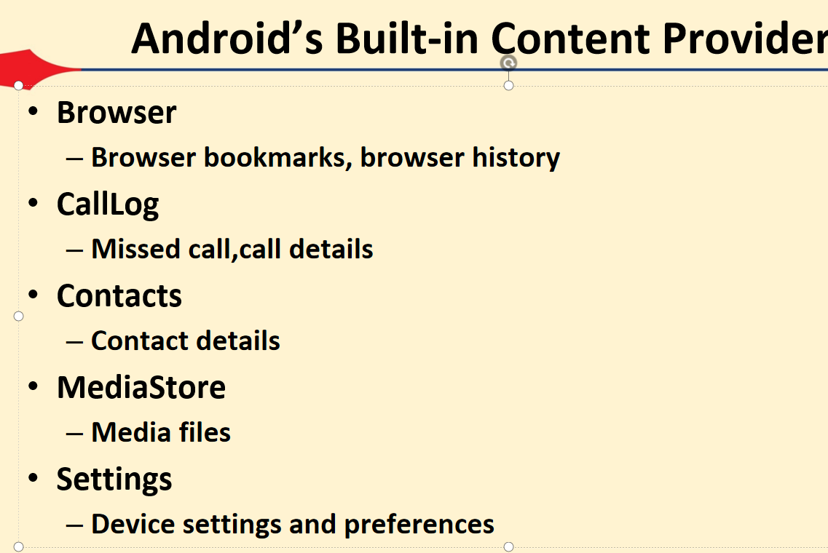

1. **Describe the CRUD operations in content providers with examples.**

**Ans :**

CRUD stands for Create, Read, Update, and Delete. These are the four basic operations you can perform on data using a Content Provider in Android. The ContentResolver class is used to perform these operations.

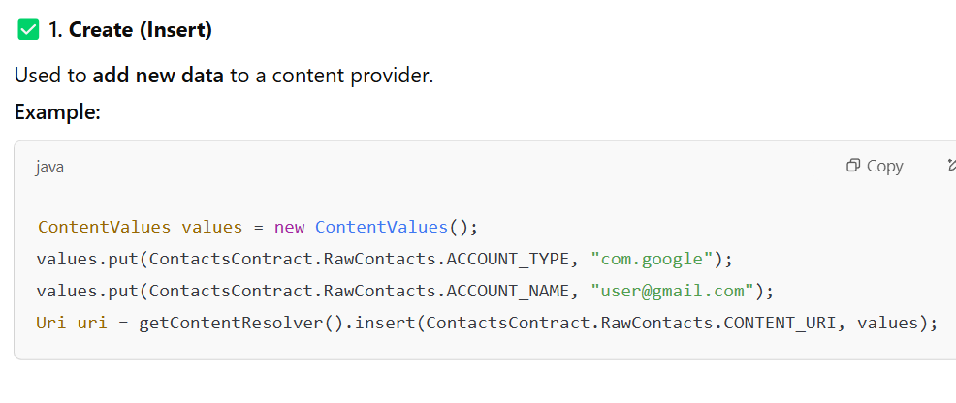

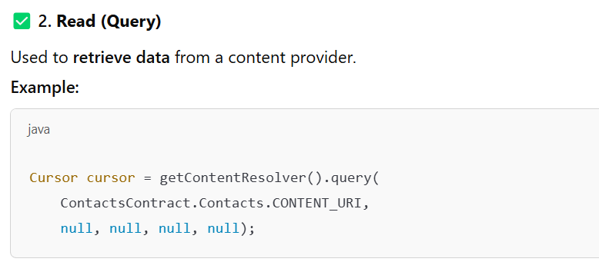

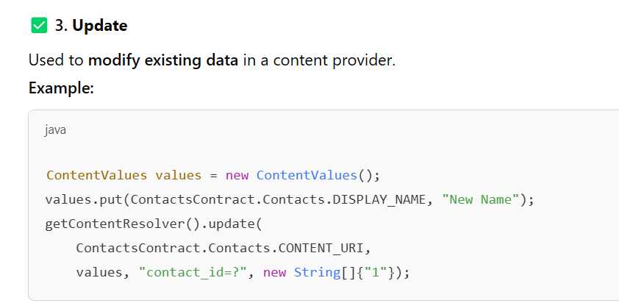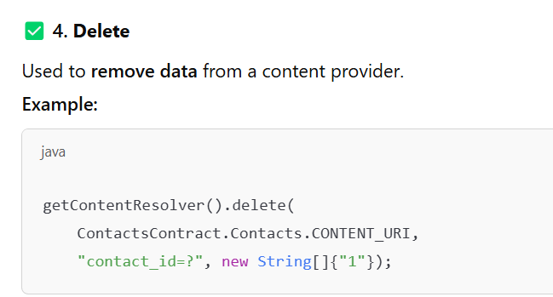

1. **What are the steps involved in retrieving data from a content provider? Explain with proper flow.**

Ans :-

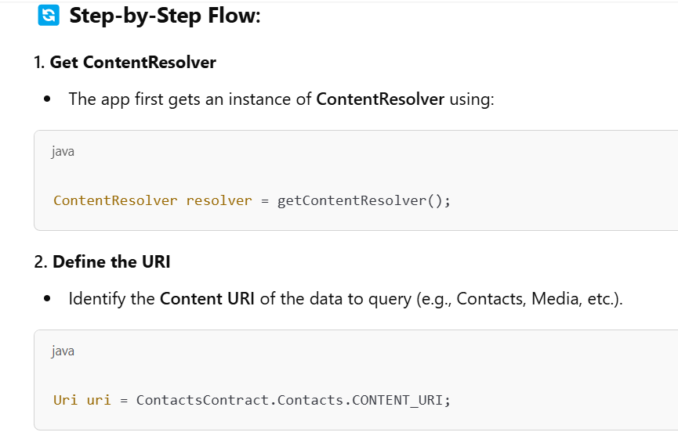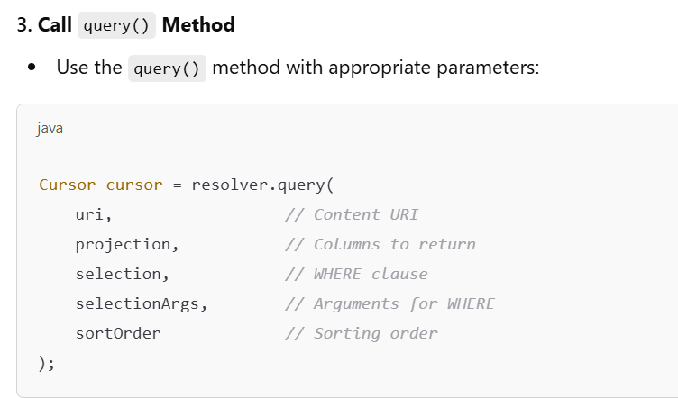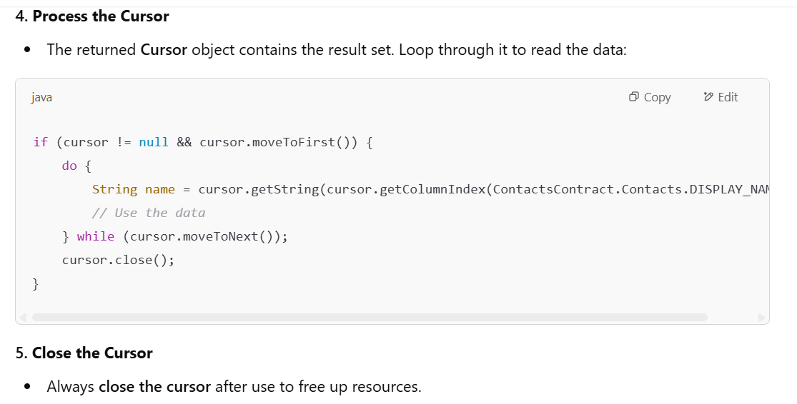

1. **Elaborate on how content URIs work, including their structure and usage.**

ANS :A Content URI (Uniform Resource Identifier) is used in Android to identify data in a content provider. It tells the system what data you want to access and from which provider.

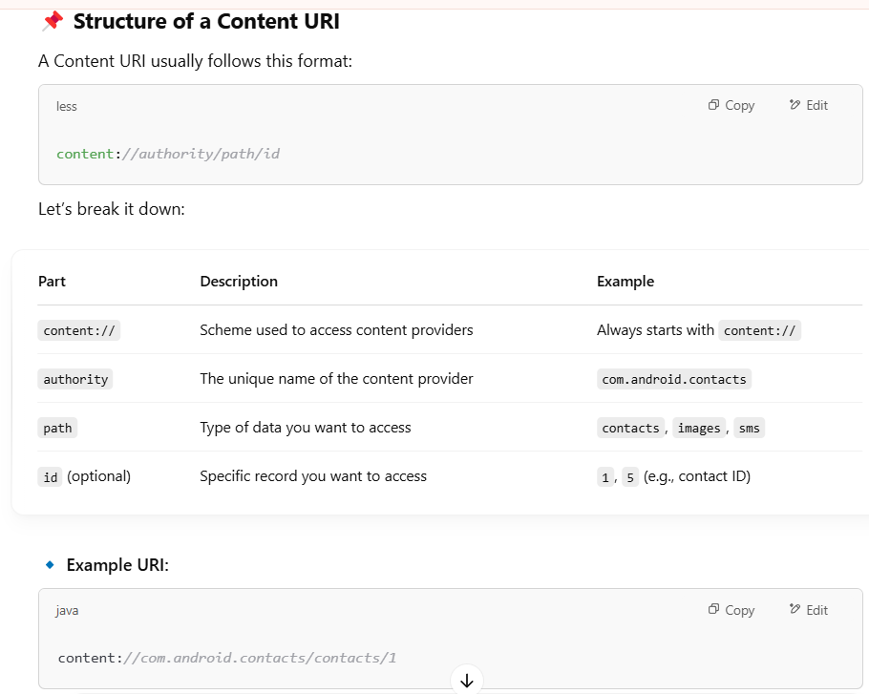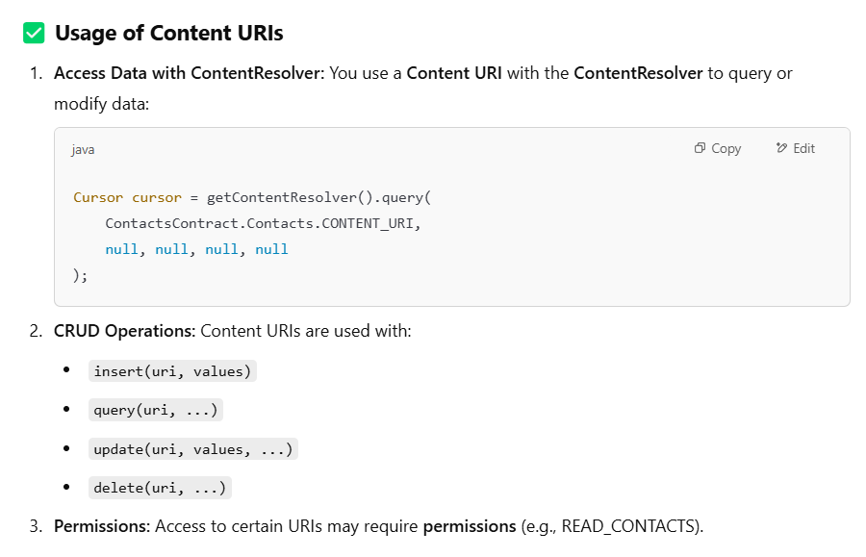

1. **Discuss the process of creating a custom content provider in Android. What are the key components involved?**

**Ans :**A Custom Content Provider allows your app to share its data with other apps in a secure and controlled way. You create it by extending the ContentProvider class and overriding its methods.

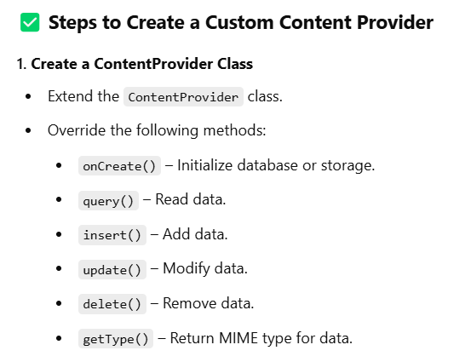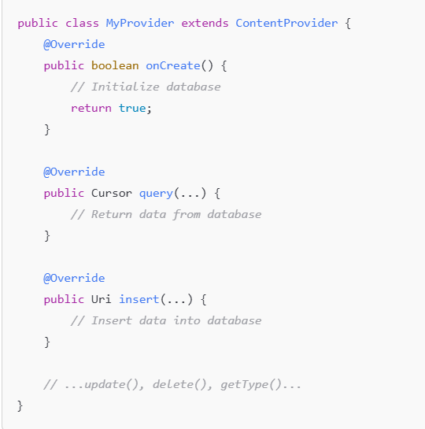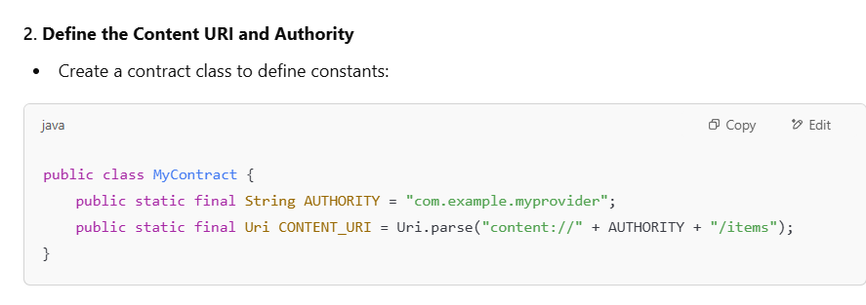

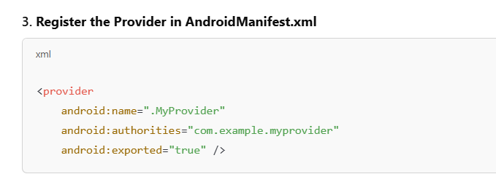

1. **Explain the role of ContentResolver and permissions in accessing content from other apps.**

Answer:

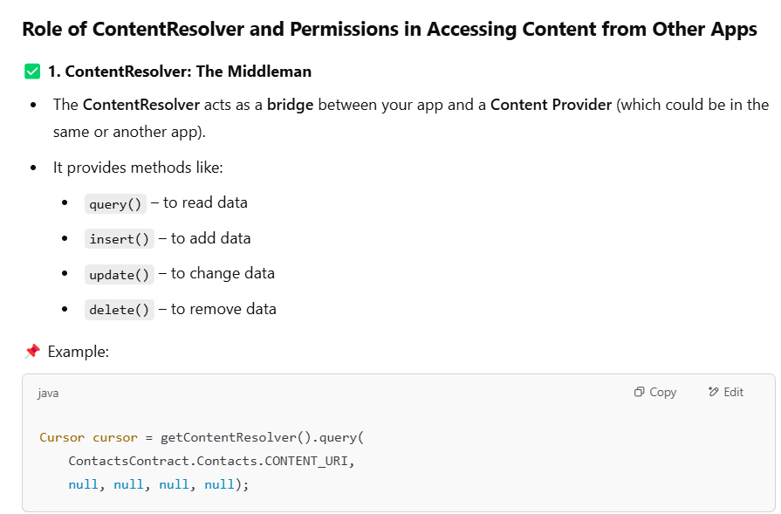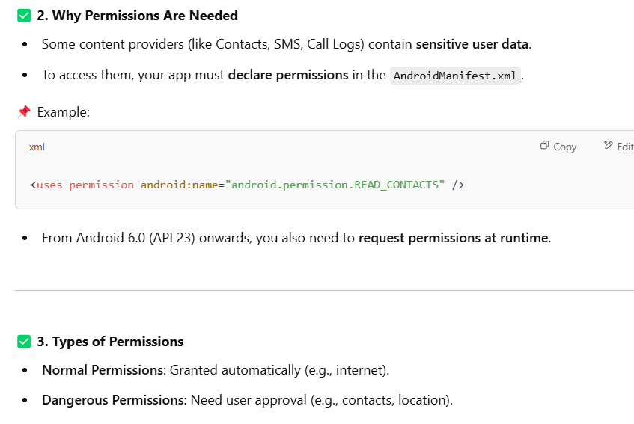

1. **Describe the arguments used while querying and updating a content provider.**

Answer:

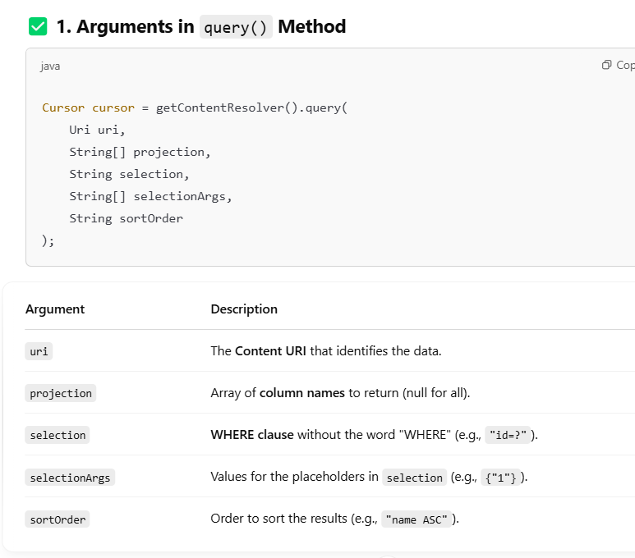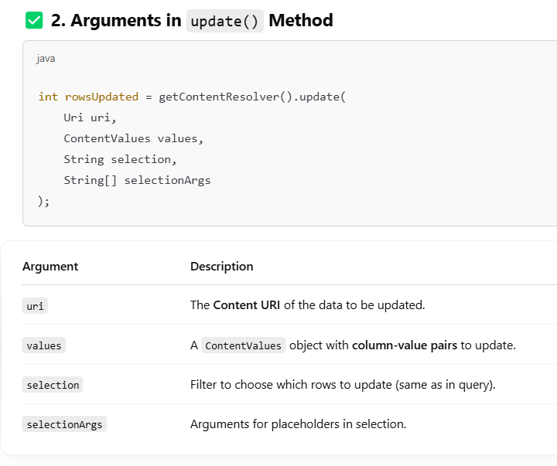

1. **llustrate with an example how call logs can be inserted and retrieved using a content provider.( Prefer chatGPT answer).**
2. **Write the steps to create a custom student database using content providers, including onCreate, insert, query, and update methods( prefer practical)**

**10.How is a custom content provider registered in the Android manifest? Provide code and explanation.**

